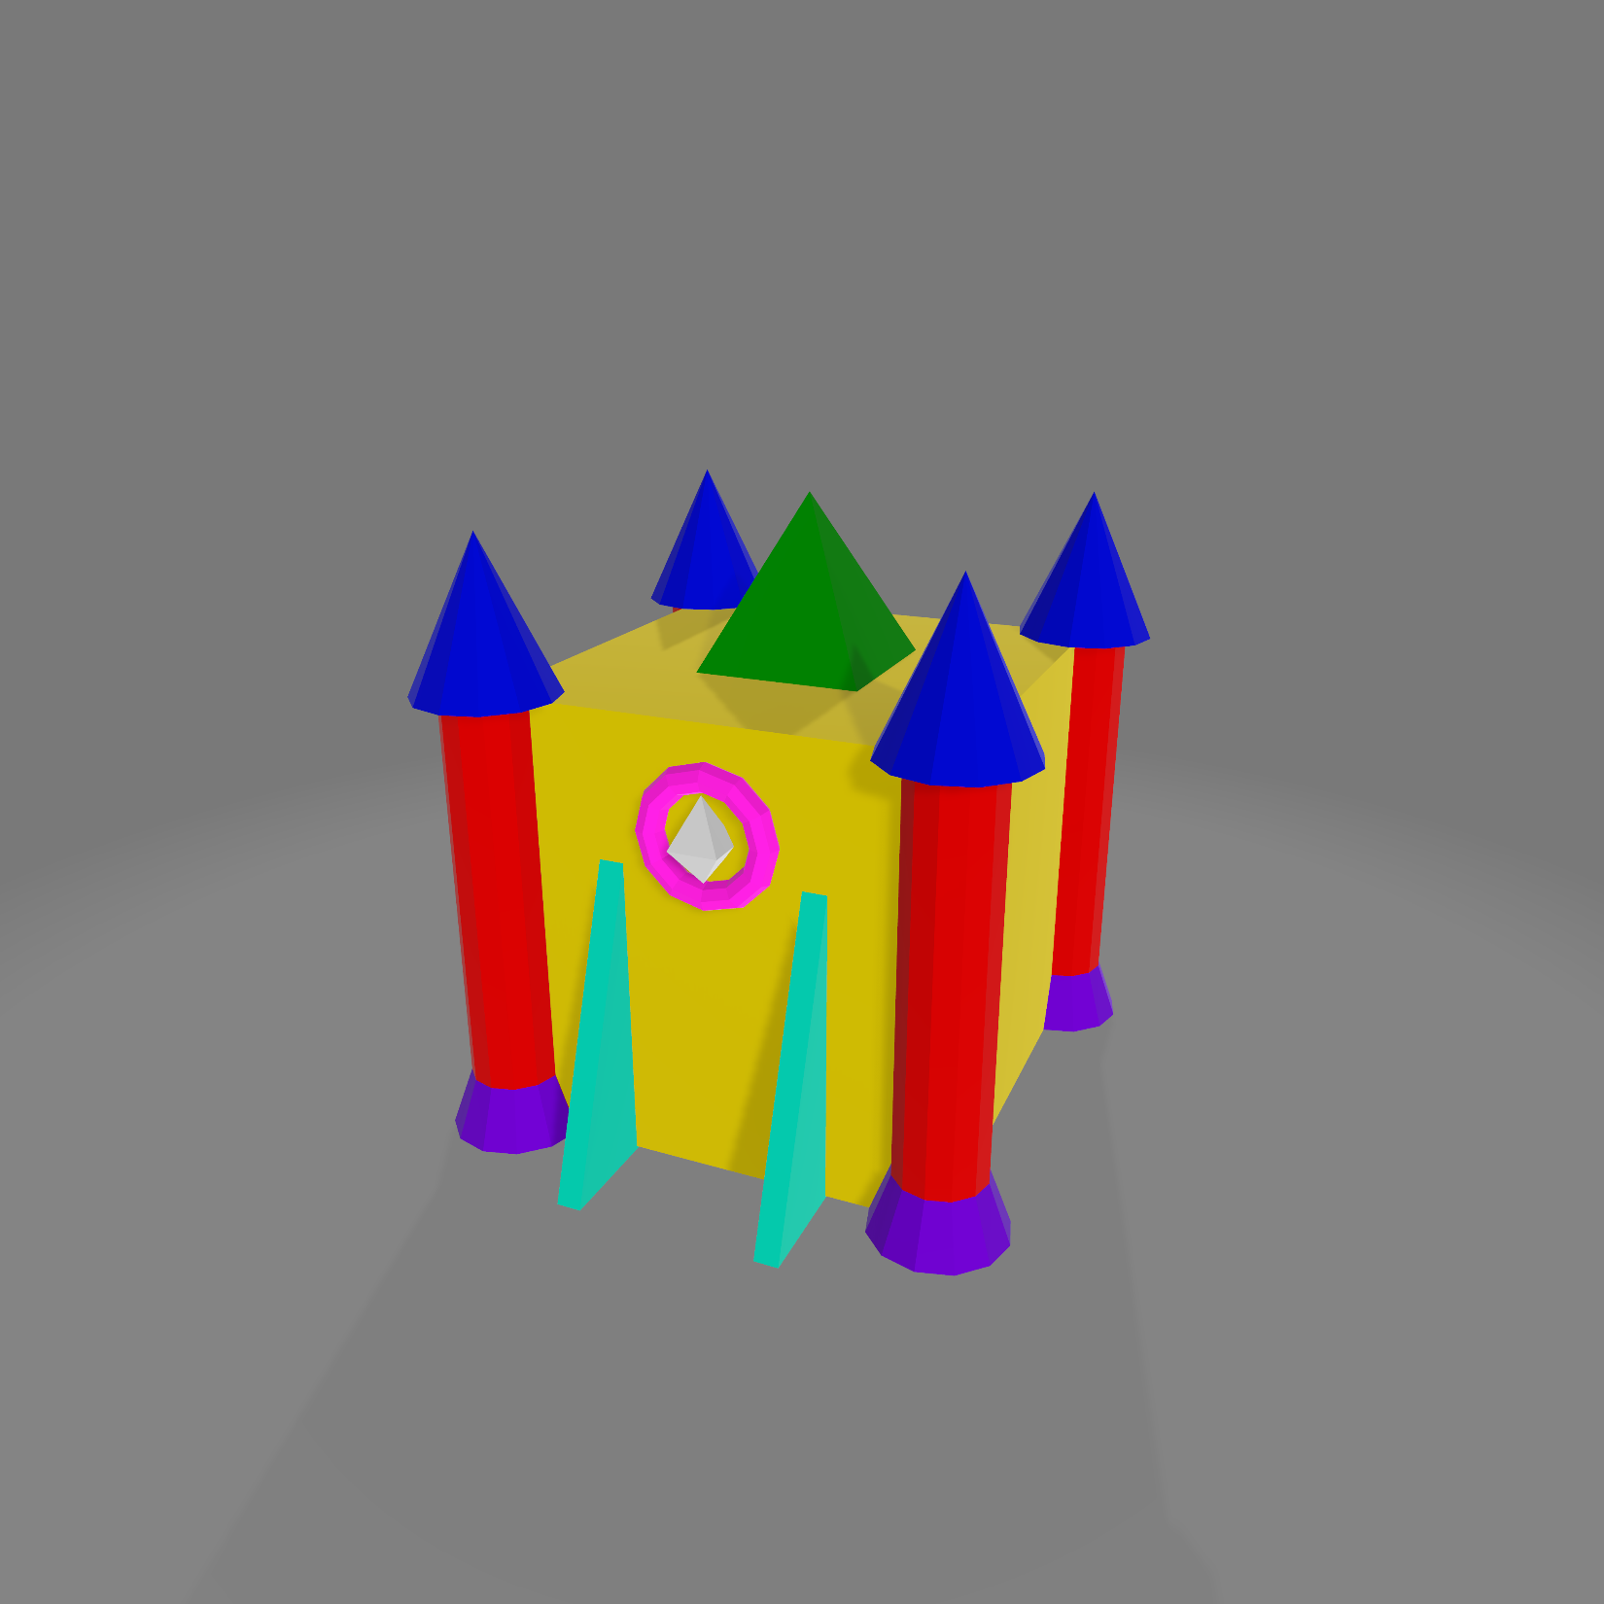
 |  | X | Y | Z | Geometry Gen Function
Castle | Box | 0 | 0 | 0 | CreateBox()
 | Pyramid | 0 | (Box.h / 2) + (this.h / 2) | 0 | CreateSquarePyramid()
Front Right Column | Cone | Box.l / 2 | (Box.h / 2) + (this.h / 2) | Box.w / 2 | CreateCone()
 | Cylinder | Box.l / 2 | 0 | Box.w / 2 | CreateCylinder()
 | Half Cone | Box.l / 2 | (-Box.h / 2) + (this.h / 2) | Box.w / 2 | CreateCylinder() where topRadius < bottomRadius
Front Left Column | Cone | -Box.l / 2 | (Box.h / 2) + (this.h / 2) | Box.w / 2 | CreateCone()
 | Cylinder | -Box.l / 2 | 0 | Box.w / 2 | CreateCylinder()
 | Half Cone | -Box.l / 2 | (-Box.h / 2) + (this.h / 2) | Box.w / 2 | CreateCylinder() where topRadius < bottomRadius
Back Right Column | Cone | Box.l / 2 | (Box.h / 2) + (this.h / 2) | -Box.w / 2 | CreateCone()
 | Cylinder | Box.l / 2 | 0 | -Box.w / 2 | CreateCylinder()
 | Half Cone | Box.l / 2 | (-Box.h / 2) + (this.h / 2) | -Box.w / 2 | CreateCylinder() where topRadius < bottomRadius
Back Left Column | Cone | -Box.l / 2 | (Box.h / 2) + (this.h / 2) | -Box.w / 2 | CreateCone()
 | Cylinder | -Box.l / 2 | 0 | -Box.w / 2 | CreateCylinder()
 | Half Cone | -Box.l / 2 | (-Box.h / 2) + (this.h / 2) | -Box.w / 2 | CreateCylinder() where topRadius < bottomRadius
Front Gate | Diamond | 0 | Box.h / 4 | Box.w / 2 | CreateDiamond()
 | Torus | 0 | Box.h / 4 | Box.w / 2 | CreateTorus
 | Left Wedge | -Box.l / 2 | (-Box.h / 4) + (this.h / 2) | Box.w / 2 | CreateTriangularPrism()
 | Right Wedge | Box.l / 2 | (-Box.h / 4) + (this.h / 2) | Box.w / 2 | CreateTriangularPrism()

